
Gnome Street Gnome
Mechanics

Lever
A lever reverses the direction of motion and can amplify motion or power.

Crank
A crank can change the direction of motion or swap from rotary to linear motion
Gears
Gears can be used to change the speed of motion or generate complex motion.
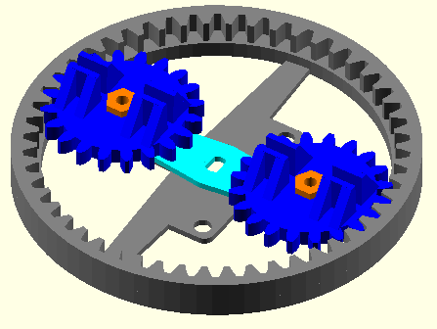
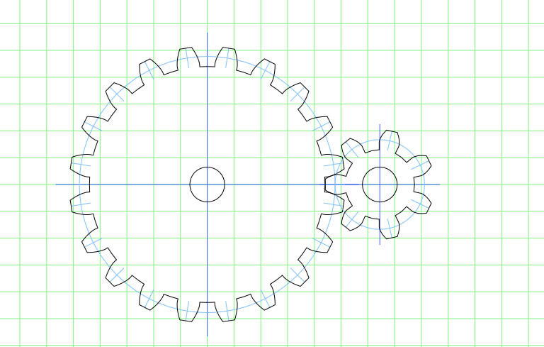
Push vs. Pull
Motion can be simplified with a string for pulling and a spring to return rather than having a hard connecting bar.

